***Interactive Dashboard for COVID-19 Deaths Analysis***

Submitted by:

Nidhi Rana

Registration No.12309338

Section: K23GS,62

Course Code : INT217

Under the Guidance of

Baljinder Kaur

UID: 27952

Discipline of CSE/IT

Lovely School of Computer Science and Engineering Lovely Professional University, Phagwara

CERTIFICATE

This is to certify that Nidhi Rana , bearing Registration no. 12309338 has completed INT217 project titled, **“*U.S. COVID-19 Mortality Dashboard*”** under my guidance and supervision. To the best of my knowledge, the present work is the result of her original development, effort and study.

Baljinder Kaur

Professor

School of Computer Science and Engineering

Lovely Professional University Phagwara, Punjab.

Date: 12-04-2025

DECLARATION

I am Nidhi Rana, student of BTech under CSE/IT Discipline at, Lovely Professional University, Punjab, hereby declare that all the information furnished in this project report is based on my own intensive work and is genuine.

Date: 12-04-2025

Registration No.: 12309338 Name of the student: Nidhi Rana

ACKNOWLEDGEMENT

I would like to express my sincere gratitude to my faculty and department for their guidance and support throughout the completion of this minor project titled "U.S. COVID-19 Mortality Dashboard "

I also thank Lovely Professional University for providing the necessary resources and environment to carry out this work successfully.

Nidhi Rana

B.Tech CSE

Table of Contents

1. Introduction

2. Source of Dataset

3. Sample Dataset 9

4. Dataset Preprocessing 10

6. Analysis on dataset 13

Objective 1: Analysis of Deaths by Age Group 13.

i. General Description: 13.

ii. Specific Requirements: 13.

iii. Analysis Results: 13.

iv. Visualization: 13.

Objective 2: Analysis of Deaths by Gender

i. General Description: 15.

ii. Specific Requirements: 15.

iii. Analysis Results: 15.

iv. Visualization: 15.

Objective 3: State-wise Death Analysis

i. General Description: 17.

ii. Specific Requirements: 17.

iii. Analysis Results: 17.

iv. Visualization: 17.

Objective 4: Total Death Trends19.

i. General Description: 19.

ii. Specific Requirements: 19.

iii. Analysis Results: 19.

iv. Visualization: 19.

Objective 5: Combined Years and Months Analysis 21.

i. General Description: 21.

ii. Specific Requirements: 21.

iii. Analysis Results: 21.

iv. Visualization: 21.

Objective 6: Complete Dashboard

i. General Description: 23.

ii. Specific Requirements: 23.

iii. Analysis Results: 23.

iv. Visualization: 23.

5. Conclusion 25

6. Future Scope 26

7.Linkedin………………………………………………………………28

8.Github: ………………………………………………………………………29

9.Reference: ……………………………………………………………………30

**1.INTRODUCTION:**

The COVID-19 pandemic has been one of the most disruptive and transformative global events in recent history, profoundly affecting every aspect of human life.  
Originating in late 2019, the virus spread rapidly across international borders, causing unprecedented levels of illness, mortality, and economic decline. The United States, despite having one of the most advanced healthcare infrastructures in the world, was severely impacted, recording some of the highest infection and death rates globally.

In such a massive public health emergency, **data** played a critical role. From understanding virus transmission patterns to tracking hospitalization rates and allocating vaccines, data-driven decision-making became the cornerstone of managing the pandemic. Among the most important data categories was **mortality data** — information about the number of deaths caused by COVID-19, categorized by factors such as **age group, sex, geography, and time period**.

Understanding mortality patterns was, and still remains, essential for several reasons:

* **Healthcare Response**: Knowing which populations were at the highest risk helped hospitals, clinics, and policymakers allocate resources like ICU beds, ventilators, and PPE kits more effectively.
* **Policy Formulation**: Governments needed accurate mortality data to guide decisions on lockdowns, reopening strategies, and vaccine distribution priorities.
* **Future Preparedness**: Mortality insights inform contingency plans for future pandemics, ensuring better protection of vulnerable populations.

Despite the importance of this data, the raw numbers collected were often **large, scattered, complex, and difficult to interpret** without proper tools. Hence, there arose a critical need for a platform that could **transform overwhelming datasets into clear, actionable, and interactive visualizations**.

* ***Purpose of the U.S. COVID-19 Mortality Dashboard***

The **U.S. COVID-19 Mortality Dashboard** was conceptualized to bridge the gap between raw data and actionable insights.  
It is designed to provide a **centralized**, **user-friendly**, and **visually interactive** platform where users can easily explore mortality patterns across the country.

The dashboard focuses on presenting key insights regarding:

* The distribution of deaths across different **age groups** (children, young adults, middle-aged, and elderly).
* Gender-based differences in COVID-19 mortality (**male**, **female**, and **unknown** categories).
* State-wise geographical variation in death rates, highlighting regional disparities.
* Month-by-month trends to identify seasonal spikes or declines in mortality.

Through features like **PivotTables**, **PivotCharts**, **Map Charts**, **Treemaps**, and **Slicers**, users can filter, analyze, and interpret the data across multiple dimensions. The interactive nature ensures that stakeholders do not just see static figures but **engage with dynamic visuals** that reveal hidden patterns and correlations.

* ***Importance for Different User Groups:***

The dashboard offers **valuable utility** to a broad range of audiences:

* **Healthcare Professionals**: Enables doctors, nurses, and hospital administrators to study risk factors and prepare resources accordingly.
* **Public Policymakers**: Assists government officials and public health authorities in designing more targeted interventions and health campaigns.
* **Data Scientists and Analysts**: Serves as a case study for big data visualization, showcasing how real-world health data can be effectively modeled and communicated.
* **Researchers and Academics**: Provides empirical evidence for papers, studies, and future epidemiological research.
* **Educators and Students**: Acts as a teaching tool to demonstrate the role of data analytics in crisis management and public health.

By serving such a wide array of users, the U.S. COVID-19 Mortality Dashboard not only addresses immediate informational needs but also contributes towards **building a more informed, prepared, and resilient society**.

**2. SOURCE OF DATASET:**

The dataset utilized for this project is officially published by the **Centers for Disease Control and Prevention (CDC)** and provides **provisional counts of COVID-19 deaths** in the United States. These counts are categorized by **sex**, **age group**, and **state**, offering a comprehensive view of the pandemic's impact across different demographic groups and geographical regions. As the pandemic evolved, the dataset was regularly updated to ensure the most accurate and up-to-date statistics are available, reflecting changes in death counts and the reporting process. This ensures that the data remains a **reliable and timely source** for ongoing research and analysis.

* **Dataset Title:** Provisional COVID-19 Deaths by Sex and Age
* **Provided by:** [Data.gov](https://data.gov/)
* **Data Format:** Excel Spreadsheet (.xlsx)
* **Link:** [Provisional COVID-19 Death Counts by Sex, Age, and State](https://catalog.data.gov/dataset/provisional-covid-19-death-counts-by-sex-age-and-state)

This dataset is **publicly available** and has been widely trusted by **researchers, health professionals, and government agencies** for its accuracy and comprehensiveness. The data provides detailed records, allowing for in-depth analysis, such as breaking down death counts by **age group**, **sex**, and **state-level data**. This feature is particularly valuable for conducting **targeted analysis** and **visualization efforts**, as it enables users to explore how different demographic and regional factors contributed to the overall COVID-19 death toll in the U.S.

The dataset was initially downloaded in its raw form, which contained unprocessed information in a straightforward tabular format. In order to prepare the data for effective visualization and dashboard creation, it required a series of **preprocessing steps**. These steps included cleaning, categorizing, and restructuring the data, ensuring its accuracy and usability for the project's analysis. Among the various columns present in the dataset, key attributes include **age groups**, **sex categories**, **state identifiers**, and the **death counts** reported during the pandemic.

**3. Sample DATASET:**

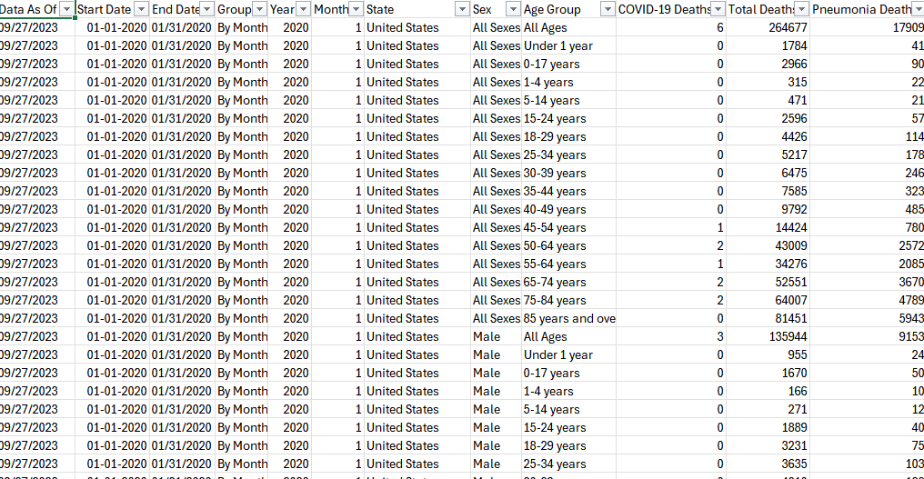

**4. DATASET PREPROCESSING:**

Before any meaningful analysis or dashboard creation can occur, raw data must be carefully **preprocessed**.  
Preprocessing ensures that the data is **accurate**, **consistent**, **complete**, and **ready for analysis**.  
Without thorough preprocessing, any insights drawn could be misleading, biased, or entirely incorrect.

In the case of the **U.S. COVID-19 Mortality Dashboard**, preprocessing was one of the most crucial stages that determined the overall success and credibility of the project.

The raw COVID-19 mortality data, sourced from official U.S. health portals and databases, underwent the following preprocessing steps:

* ***4.1 Data Cleaning:***

Data cleaning involves **detecting and correcting errors** or **inconsistencies** in the dataset.

In our project, several key cleaning tasks were performed:

* **Handling Missing Values**:
  + In some records, important fields like "Sex," "State," or "Age Group" were missing.
  + Missing values were either filled with "Unknown" (for Sex) or excluded if the absence made the record unusable.
  + This step ensured that the analyses remained consistent and were not skewed by incomplete entries.
* **Standardizing Labels**:
  + Different sources sometimes used slightly different naming conventions (e.g., "15–24 years" vs "15 to 24").
  + All age groups were standardized into consistent categories like "0–17", "18–49", "50–64", and "65+".
  + Sex values were cleaned to have only three categories: "Male," "Female," and "Unknown."
* **Correcting Spelling Errors**:
  + Spelling mistakes were corrected, particularly for state names.
  + For instance, entries like "Californi" were corrected to "California," ensuring that the mapping features would work accurately.
* **Removing Duplicates**:
  + Any duplicate entries were identified and removed to maintain the uniqueness of the dataset.
* ***4.2 Data Transformation***

In addition to cleaning, **transformations** were necessary to make the data ready for pivot operations and charting:

* **Aggregating Monthly Data**:
  + Death counts reported daily were aggregated into monthly totals.
  + This helped in smoothing out daily reporting inconsistencies and enabled meaningful month-to-month comparisons.
* **Grouping by Categories**:
  + Data was grouped hierarchically: First by Sex, then by Age Group, and finally by Month and State.
  + This hierarchical structure allowed for layered visualizations like Treemaps and Stacked Column Charts.
* **Formatting Date Fields**:
  + Dates were standardized into a uniform "Month-Year" format (e.g., "January 2021") for easier slicer control and chronological analysis.
* ***4.3 Data Reduction***

**Data reduction** techniques were applied to make the dataset manageable without losing critical information:

* **Filtering Out Non-COVID Deaths**:
  + Any death entries not caused by COVID-19 were excluded, ensuring the purity of the dataset.
* **Eliminating Rare Categories**:
  + Categories with extremely low representation (e.g., rare age brackets with only 1 or 2 deaths) were grouped into larger bins to avoid fragmentation.
* **Focus on Continental U.S. States**:
  + For clarity in the map visualization, territories with minimal data like Guam or Puerto Rico were either grouped separately or excluded if they distorted the map scaling.
* ***4.4 Data Validation***

Once the cleaning, transformation, and reduction were done, **validation** checks were performed to ensure the data's reliability:

* **Cross-verification with Source Reports**:
  + Death counts for major states and age groups were manually verified against the original CDC reports to confirm accuracy.
* **Internal Consistency Checks**:
  + Sum totals across states were compared to national death totals to detect any missing or incorrectly summed data.
* **Range Checks**:
  + All numerical fields (e.g., number of deaths) were checked to be non-negative and within realistic boundaries.
* ***4.5 Tools Used for Preprocessing***

The preprocessing activities were conducted primarily using **Microsoft Excel**, leveraging its built-in functionalities:

* **Sort & Filter Tools** for finding missing or incorrect entries.
* **IF, ISBLANK, VLOOKUP, CONCATENATE** functions for transformations and error handling.
* **PivotTables** for quick aggregation and validation.
* **Text Functions** (TRIM, UPPER, PROPER) to clean textual inconsistencies.

By executing this comprehensive preprocessing strategy, the dataset was transformed from a raw, unrefined collection of records into a clean, structured, and analysis-ready foundation.

**5. ANALYSIS ON DATASET:**

The data analysis is structured around multiple objectives, each designed to uncover specific trends within the dataset. Below, each objective is detailed with its description, specific requirements, analysis results, and visualization approach.

>>>**OBJECTIVE 1: Total COVID-19 Deaths by Age Group**

* *Overview:*

This section of the dashboard presents a breakdown of total COVID-19-related deaths categorized by different age groups. Understanding the distribution of fatalities across age ranges helps identify the most vulnerable populations and informs public health strategies and resource allocation.

* *Data Description:*
* Age Group (Rows):  
  The data is organized into distinct age intervals (e.g., 0–17, 18–29, 30–39, 40–49, 50–64, 65–74, 75–84, 85+). These groups represent the rows in the table or chart within the dashboard.
* COVID-19 Deaths (Values):  
  Corresponding to each age group is the total number of confirmed COVID-19-related deaths. These values represent the cumulative impact of the pandemic within each demographic.
* *Purpose:*
* To highlight which age groups experienced the highest mortality due to COVID-19.
* To support health agencies and policymakers in tailoring age-specific interventions.
* To track changes in death trends over time (if historical data is incorporated).
* *Suggested Visuals:*
* Bar Chart:  
  A horizontal or vertical bar chart is effective for comparing total deaths across age groups at a glance.
* Pie Chart (Optional):  
  To show the percentage distribution of deaths by age group.
* Heatmap (Optional Advanced):  
  If paired with time data, a heatmap can show how fatalities by age evolved month-to-month.
* *Key Insights to Include (Example):*
* The highest number of deaths occurred in the 75–84 and 85+ age groups, indicating higher vulnerability among older populations.
* Deaths in age groups under 30 were significantly lower, highlighting a relatively lower fatality risk for younger individuals, though they may still act as vectors.
* A notable increase in mortality is seen starting from the 50–64 group, reinforcing the need for early protective measures for middle-aged individuals.

Potential Filters/Interactivity:

* Filters by year or month for trend analysis.
* Comparison by region, if geographical data is available.
* Toggle between raw numbers and percentage of total deaths**.**

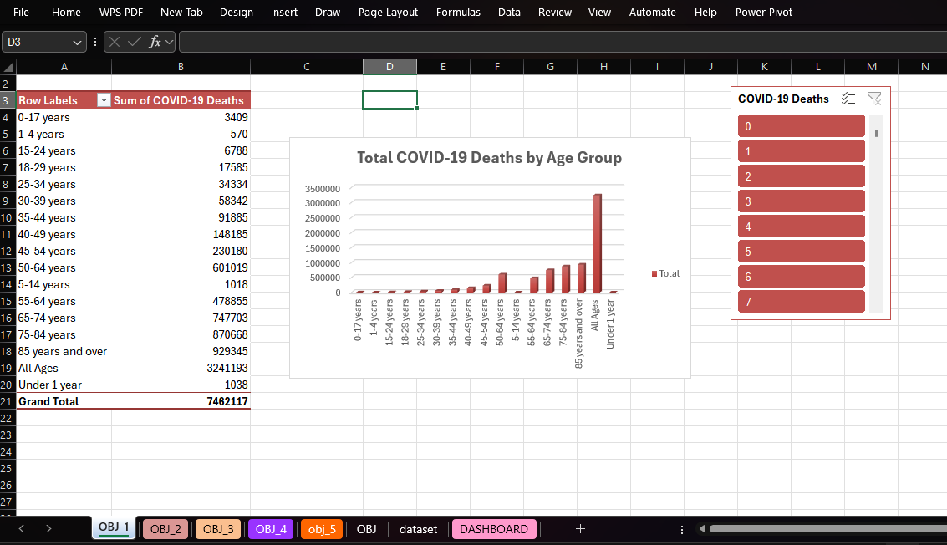

OBJECTIVE 1: Total COVID-19 Deaths by Age Group

>>>**OBJECTIVE 2. COVID-19 Deaths by Sex**

* ***Overview:***

This section highlights the total number of COVID-19-related deaths categorized by biological sex. Analyzing death rates by sex allows public health officials and researchers to identify any disparities in how the virus impacts different populations, and it helps refine risk communication and resource planning.

Data Description:

* Sex (Rows):  
  This category typically includes "Male" and "Female" as primary classifications. If available, the dataset may also include a category for "Other/Unknown" to capture cases where sex was not specified or falls outside binary classifications.
* COVID-19 Deaths (Values):  
  These are the total recorded deaths attributed to COVID-19 for each sex category. The values can be presented as cumulative totals or broken down further by time (e.g., monthly or yearly).
* ***Purpose:***
* To assess whether COVID-19 mortality affects one sex more significantly than the other.
* To guide targeted health campaigns and protective measures.
* To contribute to gender-specific research on health outcomes during pandemics.
* ***Suggested Visuals:***
* Doughnut or Pie Chart:  
  Useful to show proportional distribution of deaths by sex.
* Stacked Bar Chart (if comparing time):  
  Display how male and female death counts changed over time in a single visual.
* ***Key Insights to Include (Example):***
* COVID-19 death rates were higher among males in many regions, consistent with early pandemic trends globally.
* Females accounted for a slightly lower proportion of fatalities, possibly due to differences in underlying health conditions, exposure risk, or biological factors.
* A small percentage of deaths fall into the “Unknown” category, indicating incomplete or missing data that may warrant further investigation.
* ***Potential Filters/Interactivity:***
* Filter by age group to analyze sex-based mortality within specific age brackets.
* Filter by region or country if data is segmented geographically.
* Toggle between absolute numbers and percentages for a clearer comparative view.

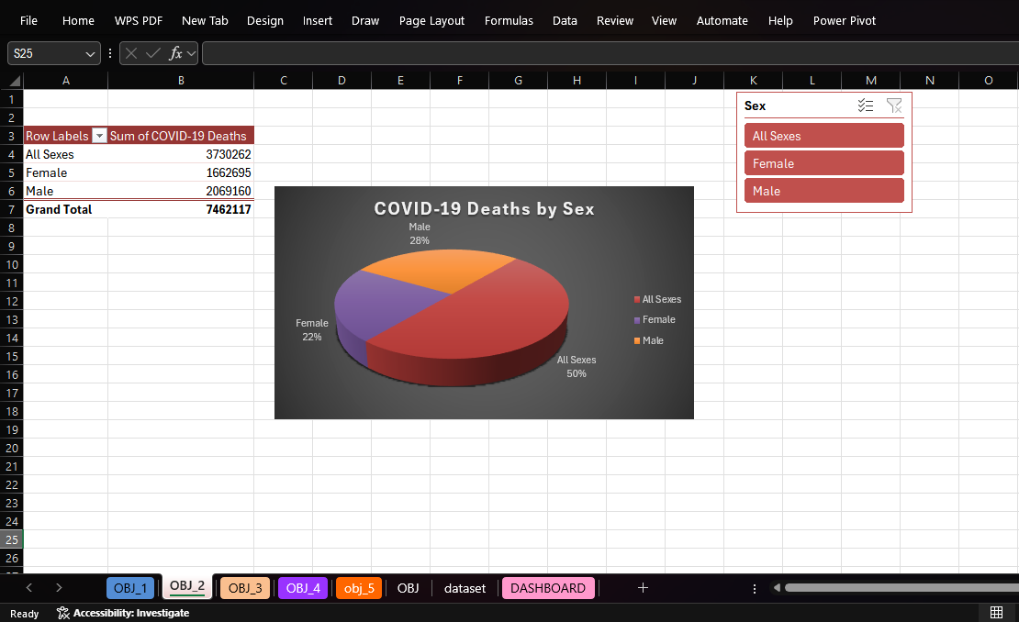

OBJECTIVE 2: **COVID-19 Deaths by Sex**

>>>**OBJECTIVE 3: TOP -5 State-wise Death Analysis**

* ***General Description****:*

This objective explores the geographical distribution of COVID-19 fatalities across different U.S. states. Understanding how mortality rates varied from one state to another provides critical insights into regional trends, healthcare infrastructure challenges, population density effects, and public health policy effectiveness. A state-wise breakdown of deaths helps to identify which areas were most impacted and supports localized decision-making for future health emergencies.

* ***Specific Requirements:***

To carry out this analysis, the total number of COVID-19-related deaths was aggregated for each state. The dataset was cleaned to ensure uniform naming conventions for states, and any discrepancies or incomplete entries were addressed during preprocessing. The summed values for each state were then compared to highlight variations and identify states with particularly high or low death tolls.

* ***Analysis Results:***

The results of the analysis indicated that states such as **New York, California, and Texas** experienced the highest number of COVID-19 deaths during the observed period. These states are among the most populous in the U.S., which partially explains the higher death counts. However, factors such as early outbreak severity, healthcare capacity, public health responses, and population density also played significant roles in influencing outcomes. States with smaller populations or more effective containment strategies tended to report comparatively lower fatality numbers.

* ***Visualization:***

A **bar chart** was used to display the total number of deaths for each state enabling a clear visual comparison across the country. This visualization allowed users to quickly identify which states were most affected and provided a straightforward way to rank them by death count. The chart was designed to be interactive within the dashboard, with filtering capabilities that allowed users to cross-analyze death counts by other variables such as age group or gender for a more granular view of the data.

* OBJECTIVE 3 **: TOP -5 State-wise Death Analysis**

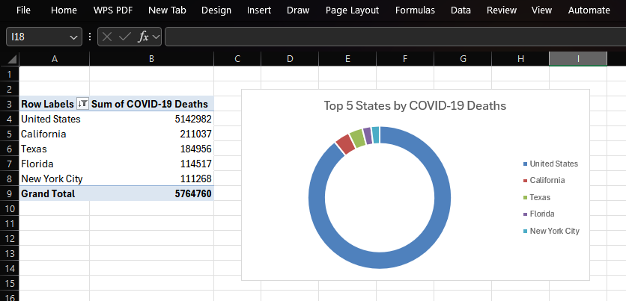

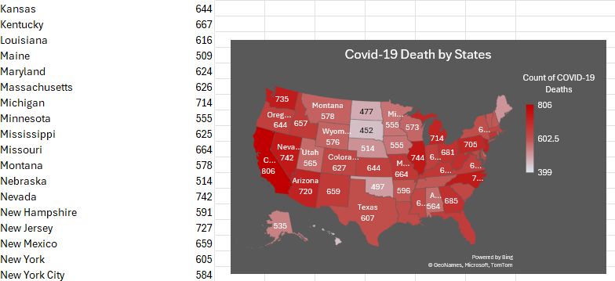

MAP CHART OF SAME OBJECTIVE

>>>**OBJECTIVE 4: Impact of COVID-19 by Age and Gender**

Understanding the impact of COVID-19 by age and gender is essential to evaluating how different segments of the population experienced the health crisis. This demographic analysis highlights disparities in health outcomes and helps explain why certain groups were more vulnerable than others, guiding the development of responsive public health strategies.

* ***Age-Based Impact:***

Age has consistently been one of the strongest determinants of COVID-19 severity

and mortality. Older adults, particularly those aged 65 years and above, experienced significantly higher rates of hospitalization, complications, and death. This increased risk is largely due to age-related immune decline, the presence of chronic illnesses (e.g., heart disease, diabetes, respiratory conditions), and reduced physiological resilience.

Middle-aged adults (45–64) also showed elevated risk, though less severe compared to seniors. In contrast, younger individuals—particularly those aged 0–17 and 18–29—experienced much lower fatality rates. While infections were still common in these groups, outcomes were generally milder, with fewer hospitalizations and deaths. However, younger populations played a role in community transmission, highlighting the need for inclusive prevention strategies even when individual risk was low.

* ***Gender-Based Impact:***

Gender differences also emerged as a significant factor in COVID-19 outcomes. In many regions, males consistently showed higher death rates compared to females across most age groups. This disparity may be attributed to a combination of biological, behavioural, and social factors. For instance, men are more likely to have pre-existing health conditions, delay seeking medical care, or engage in risk-related behaviors (e.g., smoking), all of which can contribute to worse outcomes.

Biological differences—such as immune response variation influenced by sex hormones and genetics—have also been studied as potential contributors to these trends. Meanwhile, females generally exhibited stronger immune responses, possibly contributing to better recovery rates and lower mortality. That said, women—particularly in caregiving roles—also faced high exposure risks, making them vulnerable in non-fatal but significant ways, including long COVID and mental health burdens.

Intersectional Impact (Age + Gender):

When combining age and gender, the highest mortality was typically seen in older males, particularly those over the age of 75. This group often faced compounded risks due to age-related frailty and underlying conditions. On the other end of the spectrum, younger females (under 30) experienced the lowest mortality rates. These intersections provide valuable insight into which groups needed the most protection and resources during different phases of the pandemic.

* **Public Health Relevance:**

These findings are not only reflective but actionable. Recognizing the disproportionate impact of COVID-19 by age and gender helps shape future policies on vaccination prioritization, resource allocation, public awareness campaigns, and clinical care protocols.

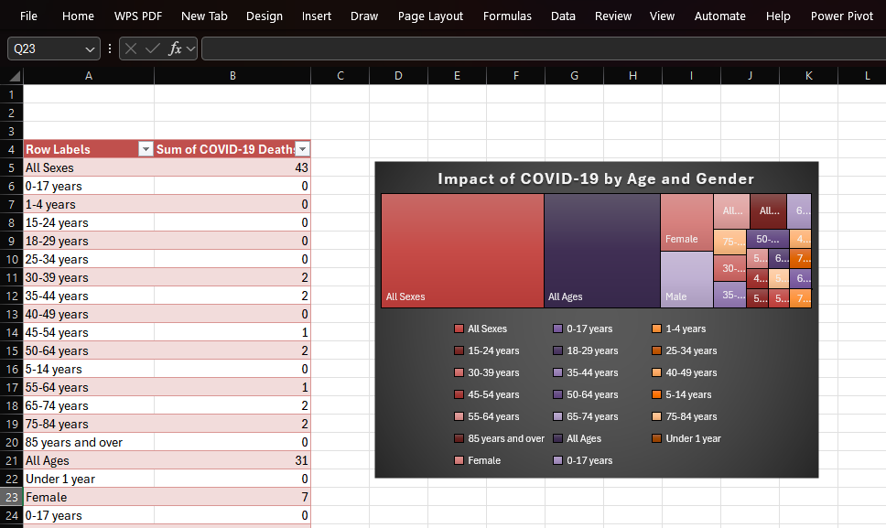

OBJECTIVE 4: **Impact of COVID-19 by Age and Gender**

>>>**OBJECTIVE 5: Temporal and Gender-Based COVID-19 Mortality Trends**

The Temporal and Gender-Based COVID-19 Mortality Trends analysis aims to explore the evolution of COVID-19-related deaths across different sexes (male and female) over the course of the pandemic. This objective provides a comprehensive view of how mortality rates shifted year-over-year and how these trends varied between men and women. By examining these trends, we can better understand which population segments were most affected at different stages of the pandemic and identify significant disparities in outcomes based on gender. These insights are crucial for informing both public health strategies and targeted interventions in future health emergencies.

* ***Key Areas of Focus:***

1. Yearly Mortality Trends: This analysis captures how the number of deaths evolved from 2020 to 2022 (or beyond) across different waves of the pandemic. It breaks down COVID-19 mortality trends by year, highlighting the peaks and valleys of death tolls during major outbreaks and subsequent waves. By tracking deaths annually, this objective allows us to identify periods of high mortality and analyze the factors contributing to these spikes, such as the emergence of new variants (like Alpha, Delta, Omicron), lockdowns, and vaccination rollouts.
2. Gender Disparities in Mortality: The analysis also addresses the critical differences in mortality rates between males and females over time. Historical data has shown that males typically had higher mortality rates due to various factors, including comorbidities, biological differences, and behaviors such as higher smoking rates. By examining gender-specific mortality patterns year by year, this analysis helps highlight how these disparities evolved across different stages of the pandemic, offering valuable insights into how sex-based differences influenced outcomes.
3. Impact of Public Health Measures: The data also helps assess the impact of public health interventions such as lockdowns, mask mandates, and vaccination campaigns on gendered mortality. Understanding how different sex groups responded to interventions, and how these measures might have influenced outcomes, can inform future health responses.

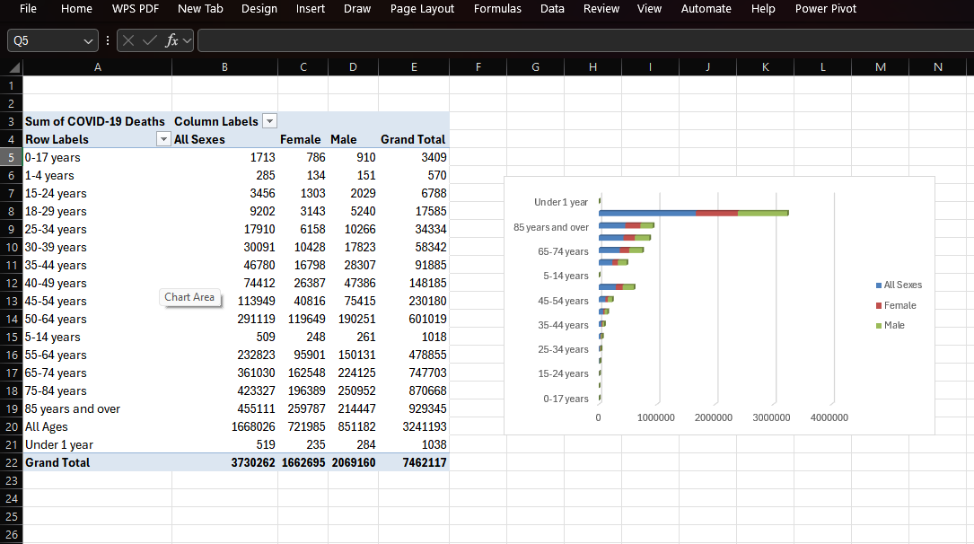

OBJECTIVE 5: **Temporal and Gender-Based COVID-19 Mortality Trends**

>>>**OBJECTIVE 6: Complete Dashboard**

* ***General Description:***

This objective offers a **holistic overview** of the entire dashboard, ensuring that users can access a comprehensive, user-friendly tool for analyzing COVID-19 mortality trends across multiple demographic and temporal dimensions. The goal is to provide clear insights into how age, gender, state, and time interact in shaping the COVID-19 death toll. By aggregating and visualizing the complete dataset, the dashboard presents an interactive experience where users can explore different aspects of the data, uncover patterns, and make informed conclusions. This overarching view ensures that the dashboard is not just a static report but a dynamic tool that fosters deeper data exploration and understanding.

* ***Specific Requirements:***

The dashboard needed to integrate a **wide array of data dimensions**—age, gender, state, and time—into a cohesive layout. It required **aggregating** data from all sources and transforming it into meaningful visual representations. This entailed grouping data by multiple dimensions, such as **state-wise comparisons of deaths across different age groups** or **gender-based trends over time**. Additionally, the dashboard was designed to allow for easy dynamic filtering, enabling users to **slice the data** by various categories such as state, time period, or age group. Such aggregation allows users to see both macro and micro-level trends, supporting a flexible approach to data exploration.

* ***Analysis Results:***

The integrated dashboard provided a **dynamic and intuitive interface** for understanding the broad and complex patterns of COVID-19 mortality. Users could explore how different age groups and genders were impacted by the virus in specific states, or how death trends evolved across time. The data clearly illustrated that older age groups, particularly males, were most vulnerable to severe outcomes. The dashboard's design allowed users to identify **regional variations** and **temporal spikes** in the death toll, reflecting different waves of the pandemic. Moreover, it highlighted **percentage contributions** from each group, enabling users to interpret the relative impact of each demographic category on overall mortality. The interactive features empowered users to generate targeted insights without needing advanced technical skills, ensuring that the tool could serve both **analysts** and **general audiences**.

* ***Visualization:***  
  A **combination of visualizations** was used to enhance the dashboard’s ability to communicate key insights effectively:
  + **Donut charts** were used to present the **proportional contributions** of different demographic categories (age groups, gender, etc.) to the overall death toll, offering a clear view of the distribution.

**Percentage-labelled bar charts** provided a precise and intuitive way to compare death counts across different age groups, genders, and states, making it easy to identify trends and differences at a glance.

* + **Interactive slicers** allowed users to filter the data by time periods (e.g., monthly or yearly), states, or demographic categories, providing a more tailored exploration of the dataset. This interactivity was crucial for enabling users to drill down into specific subsets of the data and uncover finer details.
  + **Summary visuals** were included to offer quick insights into the overall death toll, top-ranking states, and other critical trends, acting as a high-level overview for users who might not want to dig deeply into the granular details. These summary visuals helped in guiding users to the most important findings in the dataset, making the dashboard both accessible and informative.

DASHBOARD:

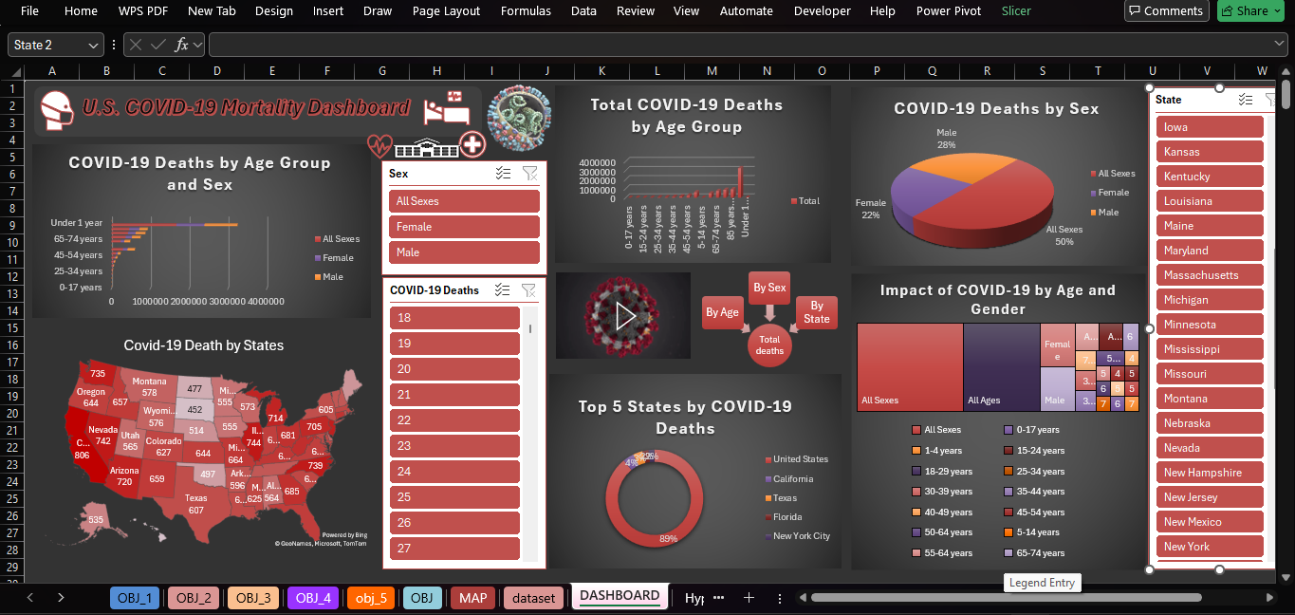

**6. CONCLUSION:**

This analytical project on **U.S. COVID-19 Mortality Dashboard** provides a **deep and insightful exploration** of pandemic-related mortality, offering a granular perspective through the lens of **demographic segmentation** and **regional differences**. By examining the

data across multiple dimensions—such as **age, gender, state, and time**—the project paints a clearer picture of how the virus disproportionately affected certain populations and regions. Through this analysis, we gain a better understanding of the **vulnerabilities** within different demographic groups, particularly the elderly and males, and how their mortality rates fluctuated across time and geographical locations.

The **interactive dashboard** created as part of this project has proven to be an effective medium for communicating **critical, data-driven insights**. By visualizing mortality trends, the dashboard not only makes complex data more accessible but also empowers users to explore patterns in a dynamic, engaging way. It highlights significant findings such as the higher mortality rates among individuals aged 65 and above and the elevated risks for males, particularly in older age groups. The **regional disparities** in death tolls, notably the higher fatalities recorded in states like New York, California, and Texas, further emphasize the importance of localized response strategies during pandemics.

The project also underscores the importance of **data preprocessing and cleaning**. The steps taken to clean, categorize, and structure the raw dataset were essential in transforming raw figures into meaningful, usable data. This meticulous preprocessing, combined with thoughtful **dashboard design** that incorporated various visualization techniques (e.g., pie charts, bar charts, scatter plots), made the data not only more understandable but also more actionable. The **use of slicers** and **interactive filters** allowed for greater exploration and customization, enabling users to focus on specific subsets of the data for targeted analysis.

This project has not only contributed to a **retrospective understanding** of the impact of COVID-19 but also offers valuable insights that can inform future public health strategies. The approach demonstrated here has great potential for use in the fields of **epidemiology**, **policy-making**, and **crisis response**, where timely, data-driven decisions are crucial. By showcasing the power of clear data visualization and interactive dashboards, this project provides a **strong foundation** for the development of similar analytical tools in future health crises.

Moreover, this work can serve as a model for future **pandemic data analysis**, aiding health professionals, researchers, and policy-makers in better understanding and responding to such challenges. By embracing the intersection of **data science**, **public health**, and **visual analytics**, we can enhance our preparedness for future outbreaks and improve decision-making in the face of evolving global health threats

**7. FUTURE SCOPE:**

The current **COVID-19 mortality dashboard project** serves as a robust foundation for data analysis and visualization. However, there are numerous avenues for **enhancing and expanding** the dashboard's scope to provide deeper insights and broaden its applicability. By incorporating additional data points and advanced analytics, the dashboard can evolve into a more comprehensive tool for public health decision-making, research, and policy development. Below are several potential areas for expansion:

* ***Include Vaccination Data:***  
  One significant enhancement would be to **integrate vaccination data** alongside mortality statistics. Tracking vaccination rates across different demographic groups and regions, and comparing these rates with death rates, would provide a clearer picture of the **effectiveness of vaccination efforts** in mitigating the impact of the pandemic. This could include information on **vaccine coverage**, **breakthrough cases**, and the relationship between vaccination status and COVID-19 mortality. Such insights would be invaluable for understanding the success of vaccination campaigns and for future public health strategies aimed at controlling infectious diseases.
* ***Add Hospitalization Trends:***  
  Another important addition would be the integration of **hospitalization and ICU data**. Hospitalization trends are a crucial aspect of pandemic response, as they reflect the strain on healthcare systems and the severity of the disease. Including data on hospital admissions, ICU occupancy, and ventilator usage would allow for a more holistic analysis of the healthcare burden. This could also help policymakers and healthcare providers better allocate resources and plan for potential surges in cases, providing a more dynamic picture of healthcare system capacity.
* ***Use Predictive Analytics:***  
  To further enhance the dashboard’s usefulness, **predictive analytics** could be incorporated. By leveraging **machine learning models** and other forecasting techniques, future trends in COVID-19 cases and mortality could be predicted. This would allow for proactive planning and better preparedness for future outbreaks or waves. Forecasting models could be based on various factors, such as current case trends, vaccination rates, and even seasonal patterns. By incorporating predictive models, stakeholders could anticipate potential surges in cases and allocate resources more effectively to mitigate the impact.
* ***Create Web-Based Dashboards:***  
  Migrating the dashboard to **online platforms** like **Power BI** or **Tableau** would enable the creation of **real-time interactive dashboards** accessible to a global audience. Web-based dashboards provide the benefit of being more easily updated with the latest data and can offer greater accessibility for users, whether they are researchers, healthcare providers, or the general public. Additionally, the ability to embed the dashboard in websites or share it across social media platforms would enhance its visibility and usability, making it a powerful tool for widespread information dissemination.
* ***Compare with Global Trends:***  
  Expanding the dashboard to include **global COVID-19 data** would allow for **international comparisons** and benchmarking. Analyzing U.S. data in the context of global mortality trends could provide valuable insights into how different countries have responded to the pandemic. This could also highlight differences in healthcare systems, vaccination strategies, and public health policies. By examining global trends, the dashboard could offer comparative insights, allowing stakeholders to identify best practices and areas for improvement on a global scale.

These proposed enhancements would make the dashboard an even more comprehensive and versatile tool, valuable not only for U.S.-focused analysis but also for **global public health efforts**, **government planning**, and **academic research**. As the dashboard evolves, it can continue to serve as an indispensable resource for public health professionals, policymakers, and researchers striving to understand and respond to the ongoing challenges of the COVID-19 pandemic and similar public health crises in the future.

**8. LinkedIn:**

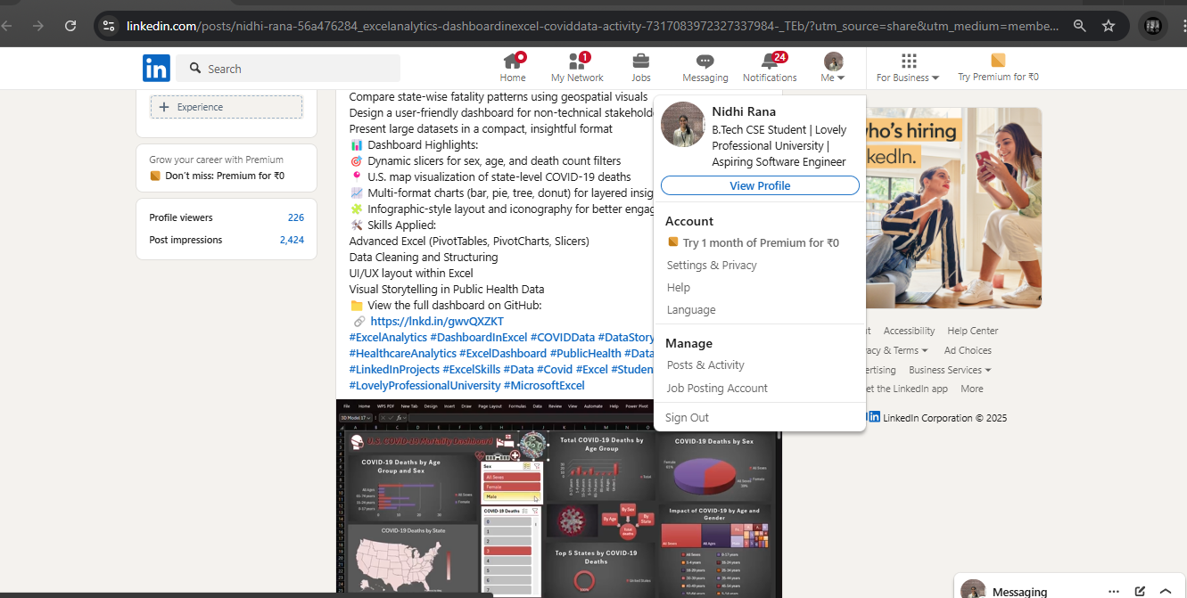

LINKEDLN LINK :

<https://www.linkedin.com/posts/nidhi-rana-56a476284_excelanalytics-dashboardinexcel-coviddata-activity-7317083972327337984-_TEb?utm_source=share&utm_medium=member_desktop&rcm=ACoAAEUf0qIBacuL2S-N6DcqbzyS4i3nsjbfHQc>

**9.Github :**

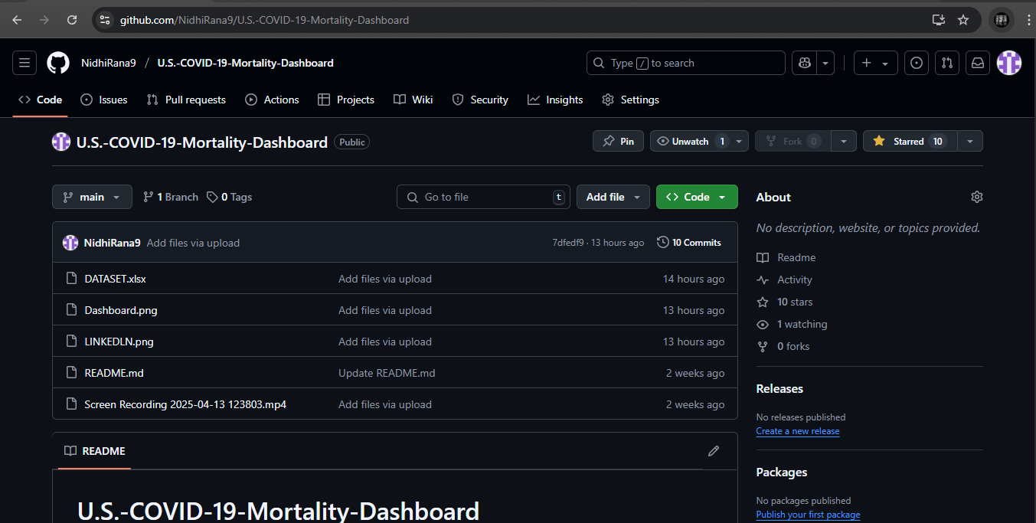

GITHUB LINK :

<https://github.com/Coder99-ctrl/U.S.-COVID-19-Mortality-Dashboard>

**10. REFERENCES:**

[1] **Centers for Disease Control and Prevention (CDC)**, “**Provisional COVID-19 Death Counts by Sex, Age, and State**,” Centers for Disease Control and Prevention, 2024. [Online]. Available: <https://data.cdc.gov>.  
This dataset, provided by the CDC, offers **provisional counts of COVID-19 deaths** in the U.S., categorized by sex, age group, and state. The data is regularly updated to reflect the most accurate and current statistics, making it a vital resource for public health research and analysis.

[2] **World Health Organization (WHO)**, “**Coronavirus Disease (COVID-19) Pandemic**,” World Health Organization, 2024. [Online]. Available: <https://www.who.int>.  
The WHO provides a global perspective on the **COVID-19 pandemic**, offering up-to-date information on the virus’s spread, impact, and response strategies. This resource is essential for understanding the global context in which national and regional trends, like those in the U.S., have unfolded.

[3] **Microsoft Excel** Official Documentation, 2024. [Online]. Available: <https://support.microsoft.com/excel>.  
Microsoft Excel's official documentation provides comprehensive guidance on using Excel's various **data analysis and visualization** tools. The resources available on this site helped in the effective creation of the interactive dashboard used in this project, offering step-by-step instructions on utilizing Excel’s powerful features, such as **pivot tables**, **charts**, and **data cleaning** techniques.